

ACTIVITY REPORT
ON
ALGOTHON
- Name of the Club: BMSCE ACM STUDENT CHAPTER
- Name of the Activity: ALGOTHON
- Objectives: Algothon's main goals were to challenge and sharpen participants' algorithmic problem-solving and coding skills through a competitive three-round format. It aimed to foster logical thinking, efficient coding, and the application of theoretical knowledge in a practical setting. The event also sought to identify talent, build a community of algorithm enthusiasts, and provide a platform for learning, networking, and sparking interest in computer science. Ultimately, it was about testing abilities and encouraging growth in the field of algorithms.
- Date, Time Venue of the Activity:
EVENT | Algothon
DATE/DAY | Thursday, 15th April 2025
TIME | 11:00 am to 1:00 pm
VENUE | SMV Hall PG Block
- Name and details of collaborating agency (if it is collaborative/joint activity): BMSCE IEEE PES & Sensors Council
- Brief summary of the Event:Algothon was a competitive event, typically focused on algorithmic problem-solving or algorithmic trading. Participants, in teams, were presented with a series of questions or challenges that required them to apply their knowledge of algorithms, data structures, and programming skills.
The structure of Algothon involved multiple rounds, and in this specific format, there were three rounds. In each round, participants worked to solve the given problems. For every question they answered correctly, they were awarded a certain number of points, which in this case was 10 points. The goal was to accumulate the highest score by correctly solving the maximum number of problems within the given time frame for each round.
- Outcomes: The participant with the most points wins the Event.
- Number of participants:
Number of Participants | Number of Volunteers
22 | 6

- Number of ACM Members:
Number of Acm Members | Number of Non-Acm Members
0 | 22

- Event Poster:
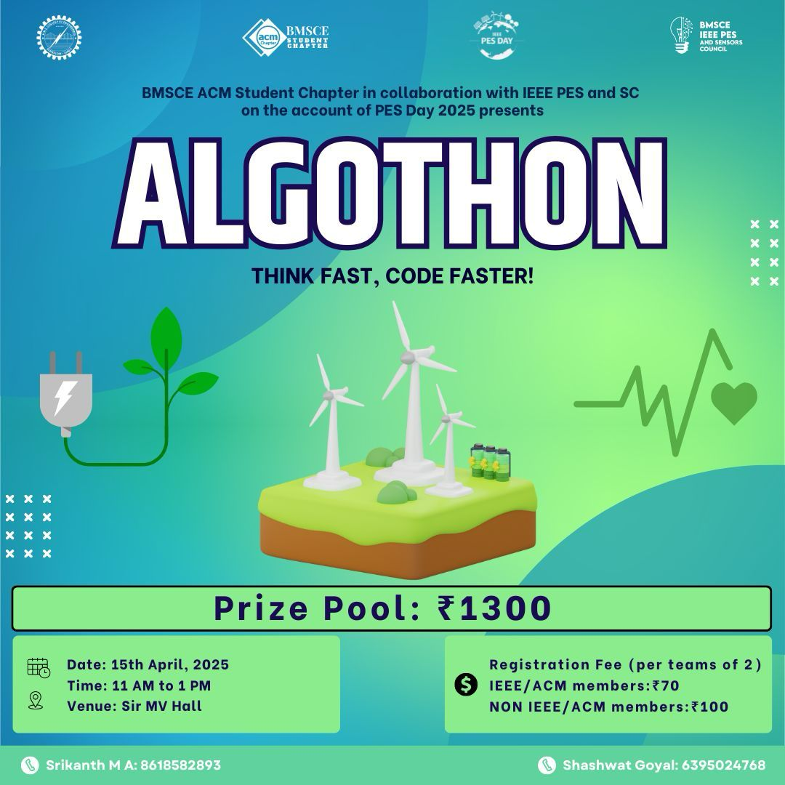

- Photographs of the event:
